DA-IICT
Software Requirement Specification
Food Chain Management

Hiren Savalia
201212024
Dipesh Kakadiya
201212046
03 Feb 2013
-: INDEX:-

Table of Contents

1. Problem Description 3

2. Documentation of Requirements Collection 3-9
2.1 Background Reading
2.2 Interview 3
2.3 Questionnaire 6
2.4 Observation 8
2.5 Fact Finding 9

3. Description of the Problem 10-16

4. Documentation of Requirements Analysis 16-19
4.1 User Categories 16
4.2 List of Requirements for each category 16
4.3 Assumptions 19
4.4 Constraints 19

Problem Statement

- Food chain Management
- Supply chain management
- Cold Chain
- Customer Ordering
- Delivering Order
- Inventory Control
- Business Performance Analysis

Documentation of Requirements Collection

- Background Reading
  - In order to understand the actual concept of Food Chain, we referred to some online articles on internet and many of them helped us forming the generalized idea about Food Chain agency as a part of Background Reading.
  - All websites are mentioned under references part, which are used as background reading.
  - http://www.merosys.com/online-food-ordering-advantages.html
  - http://www.menudrive.com/
  - http://www.mcdonaldsindia.com/
  - http://www.fooddecisionsoftware.com/food_distribution_software

- Interview:

  - Interview Plan
    - System: Food Chain Management
    - Participants:
      - Jay Kursija (Director of Sankalp PVT LTD)
      - Interview taken by:
        - Hiren Savalia (Developer)
        - Dipesh Kakadiya (Developer)
    - Date: 2/2/2013
    - Time: 12:15
    - Duration: 30 minutes
    - Place: At Sankalp Restaurant

  - Purpose of interview
    - Preliminary meeting to identify the requirements for creating system of Food Chain Management and how do it work. And what types of problems one can face at the time of creating this type of system.
    - Agenda:
      - Requirements of system (Food supply tracking and maintaining the quality)
      - Current problems (Food transportation and order)
      - Initial idea to overcome that problem (putting more emphasis on the technology)
      - Follow up action. (Create some automation for order, supply)

    - Documents to be brought to the interview:
    - Problem description Document.
    - Other documents relating to several processes of food chain.

  - Interview Details:
    - What are the primary goals for Sankalp’s food chain management?
      - The goals are to provide on time delivery of fresh food (as a raw material) and other things which are primarily used in making food.
      - Through which our Sankalp restaurant can fulfill our customer’s expectation and so we can able to serve them fresh food with 100 % quality.
    - How the distribution of the food or raw material is done?
      - At our main office where we collect the raw material, it depends on the collector agents who collect raw material from various sources depends on our requirements.
      - Some resources are contract base and some are seasonal. It depends on our agent. And that is their responsibility.
      - On the other hand at supplier, whole work is divided into areas where our outlets are residing and there are different distribution agents assigned to these areas for specific restaurant.
      - These distribution agents know everything about their areas, how the circulation should be done, what will be the shortest path.
      - Delivery boys work under these distribution agents. And we are also looking forward for any transportation company that can take care of our transportation.
      - Because our business is growing and we have to make it automated if we want to be in competition. This is how the whole work of food chain management is carried out.

    - What is the hierarchy of management in your firm and how is the work divided into departments?
      - Four departments.
      - Administration: Above all the other departments. It has the main responsibility to look after the administrative work.
      - Accounts department: It handles the accounts and generates the reports on profit or loss incurred by the agency. But here it profit or loss calculated by this department is of the whole firm and not of the only food chain management.
      - Sales department: It works for increasing the sales of the agency.
      - Transportation department: It handles the distribution of the food for different stores in different areas. But currently we are working in this because as I mentioned before, we want our department to handle by some professional agency.
    - What problems do you face in the manual systems when you have not this automated system?
      - It was very difficult to keep track of what how much sale is made or what to order and when to order to our production firm and they also face problem in supply it on daily basis.
      - Keeping track of the food raw materials details is quite cumbersome.
      - It was hard to keep track of all the things and also hard to manage all the things. And even after making it somehow automated,
      - I think there are some problems which can be fix by better use of technology.
    - Do you feel that an automation system will expand your work?
      - Of course it will.
      - If there is an automation system a central department can govern the work of different areas, which will surely expand our business. And it will easy for human to keep track all things.

  - Interview Summary :
    - Sankalp PVT LTD is very famous brand name in food industry and they have already implemented automated system for the food chain management.
    - Though their director wishes much better and efficient system than their existing system.
    - Here some points are mentioned which had make them think to improve it.
    - The current system is:
    - Traceability or tracking of the raw material is the key thing in supply of any product. So they can add this functionality in their existing system.
    - As mentioned in the interview, director wants to improve their current transport system so it can be done by some transport agents because many times food quality depends on the transportation and type of transportation.
    - Sometimes it is hard to avail the current information to other departments.

- Questionnaire:

  - We also conducted a questionnaire/survey including a set of questions on our Problem Definition which helped us to proceed ahead in our analysis and design issues and mainly deciding the features we want to incorporate. Compiled inputs of the survey are as follows:

Name:-
Phone no:-
Designation:-

Questionnaires for the survey of Food Chain Automation system

- Are you satisfied with the current manual system of managing the work of your agency?
Yes
No

- Would you like to convert your whole system into automation software?
Yes
No

- Will you find it helpful if you get the information and reports of Food production and consumption cycle from automation software?
Yes
No

- What kind of facilities would you like to have in automation software?
- Govern the work of every distribution agent.
- Have a list of each and every raw material supplied from your agency/agent.
- Profit /Loss analysis and report generation
- Agency Customer Interaction

\
- Rate it on how useful automation software would be according to you?

1 / 2 / 3 / 4 / 5 / 6 / 7 / 8 / 9 / 10

- Would you like to have whole of a Food Chain System to be automated or some portion of it? And why

- Any suggestions?

Analytical Charts on Questionnaire

- Are you satisfied with the current manual system of managing the work of your agency?
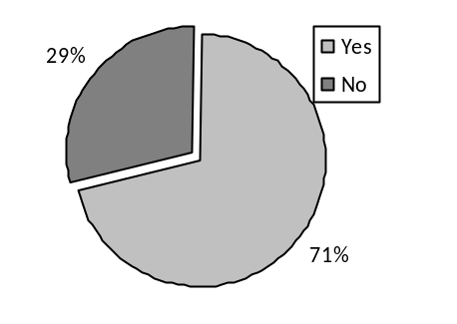
- Will you find it helpful if you get the information and reports of Food process chain and consumption cycle from automation software?
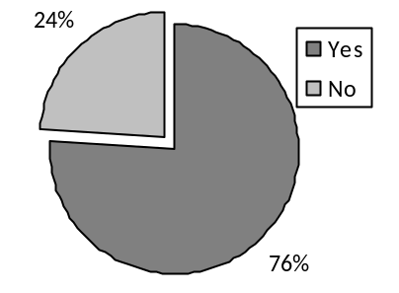
- What kind of facilities would you like to have in automation software?
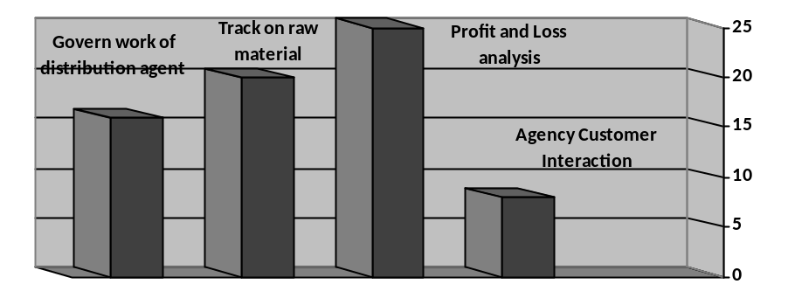

- Rate it on how useful automation software would be according to you?
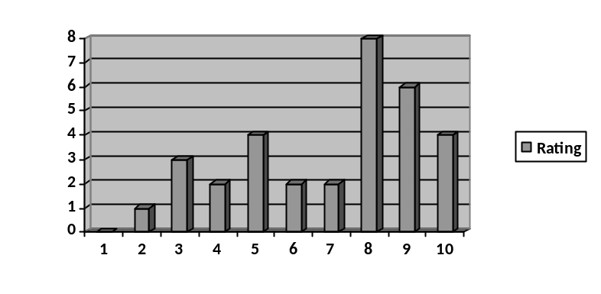
- Observations

  - 71 % of the total users of the system want to change the current system from paper base to automate because they don’t want to do book keeping stuff on their own. That clearly defines that we should now move to automated system from paper based as business is growing day by day.
  - Conclusion:- This shows that if such kind of a system is made, it will be welcomed by the users of the system.

  - 76 % of the total users want report to analyze their performance which can help them to improve their work flow. They also want to see the total consumption and production week by week. So it is clear that we should provide some automated system through which they can get these benefits easily and can make growth in their business.
  - Conclusion:-This gives us the conclusion that system should have both the modules of consumption and production of food.

  - As per the bar chart, we can clearly see that everybody wants to see final outcome of their hard work and want to catch their sweet fruits (profit). So they also know that high profit can be booked only by good and well managed automated system. Thus they can get well return of their investments as a good profit. For that the key factor is traceability of the product or raw material. Because they are spending so much unnecessary thinking on this which only increases their worry and not the profit. So traceability of the goods is the thing that they want to be there in the automated system as a well functionality.
  - Conclusion: - This gives us the conclusion that there should be a module in the system which provides the information about on which sector or in which phase of the production they are getting benefited or losing something.

  - Users are rating the system between 8-9 which is good indication for us to precede further to make this system and get avail to them as soon as possible.
  - Conclusion: - The system will be quite successful once it comes into the market.
- Fact Finding

OBJECTIVE | TECHNIQUE | SUBJECT(S)
To get background on the working of food chain management | Background Reading | Websites, Blogs and Articles about food chain management and its services
To understand the objectives of food chain management automation | Background Reading | Existing firms’ websites and their functions which have their own automated system
To understand the functionalities required for the Food Chain agency system  To understand the current scenario in the food distribution process. | Interview | Jay Kursija (Director of Sankalp PVT LTD)
To understand the use of the Food chain agency automation requirements by users of that system. | Questionnaire | Users (10 to 15 users of different designation of the Food Chain agency)

Description of the Problem

- Introduction
  - This project introduces Food Chain system. It explains how management of Food Chain is being done in various shops. The step by step procedure is explained.
  - What is food chain Management?
    - The term "food chain Management" identifies a broad range of food production-distribution-consumption configurations.
    - Such as farmers' markets, farm shops, collective farmers' shops.
    - Food chains look to logistics service providers with a similar craving for made-to-order selectivity, quality, and service—all at an affordable cost.
    - Food supply chain depends on distance and/or number of intermediaries between producers and consumers
    - Example: McDonald's
      - McDonald's is a name which is today synonymous with the fast food.
      - McDonald's is a fast food chain with restaurants all over the world with headquarters in US.
      - It serves burgers and other fast food customized to local tastes. Its philosophy has been 'one world, one burger;' which meant that the burger must be consistent in terms of cost and quality.
      - To meet such high standards, it was essential to have an excellent supply chain management system.
      - In India, McDonald's had a very well orchestrated supply chain, called the 'Cold Chain'

  - What is Supply chain management?
    - A supply chain a system of organizations, people, technology, activities, information and resources involved in moving a product or service from “Supplier” to “Customer”.
    - Supply chain activities transform natural resources, raw martial and components into a finished product that is delivered to the end customer.
    - Supply Chain Management involves the planning and management of all activities involved in sourcing and procurement, conversion, and all logistics management activities.
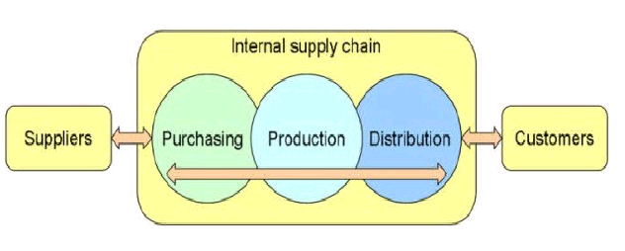
    - It is also includes coordination and collaboration with channel partners, which can be suppliers, intermediaries, and customers.
    - Supply chain management integrates supply and demand management within and across companies.
    - Supply Chain Management is an integrating function with primary responsibility for linking major business functions and business processes within and across companies into a cohesive and high-performing business model.
    - It includes all of the logistics management activities noted above, as well as manufacturing operations, and it drives coordination of processes and activities with and across marketing, sales, product design, finance and information technology.”
    - “The primary objective of supply chain management is to fulfill customer demands through the most efficient use of resources, including distribution capacity, inventory and labor”
    - Advantage of the Supply chain Management in Food Chain Management.
      - Minimizing cost
      - Cut down the delivery time
      - Improve the profits
      - Maintain the highest standards

  - What is Cold Chain?
    - A cold chain is a temperature-controlled Supply chain Management.
    - An unbroken cold chain is an uninterrupted series of storage and distribution activities which maintain a given temperature range.
    - It is used help extend and ensure the shelf life of products such as fresh agricultural produce, processed foods, chemicals and pharmaceutical drugs.
    - This concept of cold chain in food industry and that too on such a large scale was started by McDonald only.
    - It benefited both farmers as well as the consumers, as they are getting the fresh, best quality and great value food.
    - Using its food provide company cut down wastage and able to maintain its freshness and nutritional value of raw material.
    - Steps involved in cold chain concept…….
      - Procurement
      - Warehousing
      - Transportation
      - Retailing all the above activities took place in temperature controlled atmosphere.
      - Picture of a temperature controlled truck.

  - Process of Food Chain?
    - While the supply chain at first glance appears simple, its diverse components are both critical and multi-layered.
    - Food ingredients are mostly supplied by two categories,
    - Tier-I and Tier-2 suppliers.
    - Tier-2 suppliers comprise growers and processors who include importantly, lettuce and potato growers, poultry farms and companies
    - The ingredients are supplied to Tier-I suppliers who process them, for instance
    - The products are then transported in a dedicated fleet of refrigerated trucks to the company’s Distribution Centers.
    - Multi-temperature and single temperature trucks then transport the fast food swiftly to the restaurants across the country.
    - The supply-chain of has also been expertly devised to include the significant aspect of return logistics
    - The supply-chain of the fast food chain is in effect a hub-and-spoke model because the Distributors act as hubs.
    - This whole System Work like Internet network
    - Like Data passes at one to other place through Hub and switch. Hear instant of Data we have Food and in place of Hub and Switch, there are Distributors.

  - What are the basic pillars to get success in this Field :
    - Menu:
      - When you start new business in food industry, this is the main attraction among the people.
      - Because if your menu is somehow different then the others having the same business as yours, you will definitely going to get benefit through your unique product.
      - For that you will face many questions like raw material availability, environment, human resources etc.
    - fresh Food :
      - If you somehow manage to have a great and unique menu for your customers then also it is not guaranteed that customers will happy with that.
      - You have to provide them that much qualitative food and should maintain value for money law.
      - While having the food, customers will look for quality and freshness. So again here many questions will rise like even if we have availability of raw materials, are we able to maintain its quality or not?
    - Services:
      - These two questions are related to our customers.
      - The first question under this label is “Are we going to provide home delivery or not?”
      - Second is “Self-service at the store?”
      - Now questions about raw material providers.
      - “Are we providing them any facility for their service to us?”
      - Example: If we want to start our business in such area where our raw material is not natural source and we fully depends on the farmers for the raw material. At this point we have to provide free training or some financial benefits to farmers. Without this service we can't proceed further.
    - affordable Price:
      - Unique item in the menu can attract the customers but then after looking at the item they will surly look for the good and right price for that item because after all, all the customers always look for value for money.
      - We have to maintain price in such a manner that our business runs smoothly and grows periodically.
      - So balancing between two these is itself a big question and a challenge.

  - Purpose
    - Purpose of this document is to make designers, testers, developers and users wellaware of all the functions that are implemented in this system.
    - This document contains all the software requirements that can help a designer to design a system to satisfy those requirements that are demanded by the users and testers to test the system to meet the requirements properly.
    - Purpose of this system is to offer facility to scrutinize and provide a wide range of features and facilities so that the users can perform wide variety of tasks easily to manage the routine work of Food Chain System.
    - The system mainly focuses on managing the administration of System, managing the sales and most important task traceability of the raw material and the final product.

  - Scope
    - Scope of this project in any Fast Food Company use by locally i.e. contain the all the information about Fast food management.
    - Administrator can see all information about distributor, inventory, and other staffs.
    - Distributor Head can handle information about all Distributors.
    - This system will provide facility to manage and maintain data efficiently, so Users can perform various tasks on data easily
    - The users will be able to perform various basic data operations like calculation in order to maintain and analyze the system.
    - The project is an attempt to make all the tasks can be performed in easy and fast manner in order to maintain the system.
    - This system will also provide the facility to scrutinize the system in order to compete in the market.
      - Traceability of the raw material
      - Traceability of the final product
      - Customer management
      - Accounts managements
      - HR management
  - Project Perspective
    - The perspective is to build Food Chain automation plan, to support Food Agency that work with different kinds of clients and track progress of the product/raw material distribution workflow to ensure turning plans into reality.
    - They must have to track their all the products to maintain the production and raw material consumption cycle. Such a kind of software is especially helpful in agencies that professionally want to expand their area of Food Chain Management, increase the customer satisfaction level and ultimately want the growth of their agency.

  - Product Features
    - Provides the secure and authenticated system so that only intended users can use and access the system according to their role.
    - Users can perform various tasks such as calculation of revenue, timely analysis, usage of raw materials, daily food raw material consumption calculation and reports as per their requirements …etc. easily and fast.
    - User can easily browse through the database or just perform a search operation to access the specific information.
    - This system will reduce the work load of the staff as will reduce the paperwork.

  - Study of System:
    - Problems and weaknesses of current system
      - The need to manage Repetitive Customer orders
      - The need to manage products that expires
      - The need to sell in multiple units of measure
      - The need to have multiple pricing scenarios
      - The need to have Product Traceability
      - The need to manage continuous fluctuations in inventory
      - The need to manage routes

    - Requirements of new system
Customer Ordering:
      - Know what the Customer previously purchased
      - Know the specific price of a product for each Customer and the history of what they paid
      - Know the inventory status of the product your Customer is ordering
      - Customer Order Management is all about managing the repetitive process of receiving orders from your valued Customers.
      - By making it easier for them to place their orders without causing them extra stress, they will be happier.

Delivering Order
      - For a food distributor, picking, planning and organizing deliveries is an art that must be performed efficiently with accuracy.
      - You need access to well-organized and available information to find products quickly, build a route and deliver an order on time.
      - Efficiently transfer orders to the warehouse
      - Know where products are located in the warehouse
      - Be able to easily manage routes
      - where your drivers are delivering
      - Be able to handle order change

Inventory Control
      - Products to ship on any given day without having any under stock or overstock of inventory requires constant analysis of inventory levels.
      - Be aware of inventory levels
      - Know when products will be expiring
      - Know when product deliveries are due to arrive

Business Performance Analysis
      - To quickly determine the overall status of your company
      - Know the status of your Accounts Receivable and Payments
      - What your Inventory Investment is.
      - Gain a Competitive Advantage over other Food Distributors being more flexible with prices
      - Maintain a high level of order

Documentation of Requirements Analysis

- User Categories
  - There are primarily two user classes:
    - Admin:
      - This class includes all the persons who are actually working in the Food Chain Management System and hold some designation such as Manager, Accountant.
      - These people can use the system to keep a watch on their counter parts and get to know where they stand in the competition.
      - They also can get a feedback from their customers about their work that helps them in planning their next move.
      - There are two different users under this class:
        - Manager: - Some key persons who will manage the food chain all the way.
        - Accountant: - They will keep very important data about the selling and purchasing of the raw material needed for the food chain
    - Operator:
      - This category holds a more number of users. These are the people from various departments of agency that can have limited access in order to manage the system according to their needs. These all the access rights are defined by the Admin of the system.
      - There are two different users under this class:
        - Sales Executive: - Responsible for selling of raw food materials
        - Distribution Agents: - He will be responsible for distribution.
        - Raw material collector: - He will collect the raw materials from various sources to full fill their customers’ needs.

- List Of Requirement For each user

  - Functional Requirement(User Requirement):
    - Administrator:
      - Users can access all the details (data) about the system.
      - The visibility of these details can be managed through the system by Administrator, so that only some part of data is accessible to other users according to their rights.
      - Users can have the access to the rich system database of all the data entities such as Customer details, financial details and any other core information about the system.
      - Users can scrutinize the system and can easily measure how to improve performance of the agency. They are able to manipulate and update all the data regarding all the users and the music resources.
      - They should be responsible for updating data whenever needed.
      - Manager
        - Manager will have different interface for performing different functions
          - Manage User Accounts.
          - Analyze the revenues.
          - Analyze the user feedbacks.
          - Analyze overall Growth.
          - Manage Employee Details and salary.
        - Analyze the revenues
        - Analyze the user feedbacks
        - Analyze the total chain management
        - To quickly determine the overall status of your company
        - Know the status of your Accounts Receivable and Payments
        - What your Inventory Investment is.
        - Gain a Competitive Advantage over other Food Distributors being more flexible with prices
        - Maintain a high level of order.
      - Accouter
        - Accountant will have different interfaces to perform various functions such as:
- Employee Salary distribution.
- Monthly Customer bill generation.
- Monthly revenue generation.
- Generate monthly revenue growth reports.

    - Operator:
      - User can access the only limited data according to their need in order to perform their tasks.
      - They can do basic tasks such as data entry, access the information only related to their task
      - Efficiently transfer orders to the warehouse
      - Know where products are located in the warehouse
      - Be able to easily manage routes
      - where your drivers are delivering
      - Be able to handle order change
      - Sales Executive:
        - Sales Executive will have different interfaces to perform various functions such as:
        - Review of customer feedback to admin
        - Analyze monthly revenue growth
        - Analyze customer feedback
        - Frames policies to increase the number of customers
      - Distribution Agent:
        - Distribution Agents will have different interfaces to perform various functions such as:
        - Manage(insert/update/delete) customer details area wise
        - Manage(insert/update/delete) customer subscription
        - Can view generated bills
        - Customer bill amount collection
        - Inserts Customer feedback.

  - Non-Functional Requirement:
    - Performance Requirements
      - The System on that we are working on will be accessed by the operators and the administrator.
      - There might be many hardware constraints on the system. But we hope to provide maximum bandwidth so that all the facilities of the system are availed without undesirably long delay.
      - There might be very high load on the server. Therefore sever should be able to handle multiple concurrent requests efficiently. It also can be operated on many various operating systems.

    - Safety Requirements
      - The updates of the database must be moved to secondary storage device and external storage at specific time intervals so that in case of power loss or any other damage, the data safety is assured.
      - There must be a facility of power backup which assures that data can be safely saved on non-volatile storage in case of power failure.

    - Security Requirements
      - The personal data regarding the user needs to be kept confidential.
      - There should be data encoding mechanism to prevent unauthorized access of data by external harmful software entities.
      - There should also be a password mechanism so that only certain high officials can access and modify this data.
      - Login mechanism should also be provided at user level so that each user can only access the data related to him/her.
      - There needs to be a mechanism which allows user to access and modify the database concurrently. This concurrent data access should preserve data integrity.

- Assumptions
  - Once the system is in operation, there will not be any major changes in the database architecture in the back-end.
  - The system will not need any changes to support any new functionality that need to be included.
  - It’ll be a time bounded project i.e., the resources and time taken to built the system will be limited.
  - Every user must know how to use a computer and have access to a computer which has an internet connection or the system server.
  - There should be efficient and consistent power backup supply to the server.
  - The system is highly dependent on the LAN (Local area network).

- Constrain:
  - Constraints need to be applied in any system to restrict the scope of the project to some extent so that the project can be true and manageable.
  - Following are some of them that will be applicable to this system:
  - Data Volume Control – A restriction on the redundant data when the user (Operator) enters the data.
  - Data validation is required in order to protect the system from fake data.
  - Unauthenticated access is not allowed as every user of the project system will have to log in with unique username and password in order to maintain system security.
  - The system is following client-server architecture as server needs to be started when client has requested.
  - The database should be updated instantly whenever user performs any transaction activity in the system.
  - The Searching mechanism needs to be fast as there’s going to be a large number of links for the resources in the database and extracting particular query from the whole data pool is a tough task.

